|  |  |  |  |  |
| --- | --- | --- | --- | --- |
| **Document Revision** | | | | |
| **Date** | **Rev.** | **Description** | **Author** | **Approved by** |
| Sep 04, 2012 | 1.3 | Initial proposal | D. Bennett | O. Henry-Blair |
|  |  |

**Table of Contents**

|  |  |
| --- | --- |
|  | **Page** |
| Document Revision | 1 |
| **1.0 Introduction** | 2 |
| 1.1 Purpose | 2 |
| 1.2 Solution Overview | 2 |
| **2.0 User Description** | 2 |
| 2.1 Key User Needs | 2 |
| **3.0 Database Software Solution** | 3 |
| **4.0 Documentation Requirements** | 5 |
| 4.1 Code documentation | 5 |
| 4.2 System manual | 5 |
| 4.3 User manual | 5 |
| **4.0 Appendix** | 6 |
| Figure 1 - Testing and verification of weighing and measuring devices | 6 |
| Figure 2 – Modified Testing and verification of weighing and measuring devices | 7 |
| Figure 3 – Service Request and Job Tracking Process | 8 |

**1.0 Introduction**

This document provides the current vision for the BSJ Legal Metrology Database software. This document was developed in collaboration with various stakeholders and the intended users of the software.

**1.1 Purpose**

The primary purpose of this database software is to streamline the collection, authorized modification of data used by the Legal Metrology Inspectorate of the BSJ’s Inspectorate division in carrying out its daily activities. The secondary purpose of the software is to facilitate the extraction of information from the database for the purpose of generating various reports and for performing data analysis.

**1.2 Solution Overview**

A multiuser database software is proposed to provide the specific needs and features outlined in this document. The user interface of this software will be browser-based. The user will connect to a central database using this interface (via an application server). This will enable the system to be accessed via a computer and any mobile device that has a suitable Internet browser installed.

The browser-based interface will facilitate the entry of data via forms. Whenever it is required, information can be extracted from the system and presented as web pages, PDF documents or Excel spreadsheets.

The software will transparently connect to the BSJ’s Job Management and Tracking System (JMTS) database software to access job related information whenever it is required.

**2.0 User Description**

The intended users of the system are BSJ inspectors, managers and directors. These users are expected to use the software to accomplish the following:

* Enter, view and update databases records in office using a personal computer
* Capture data in the field of work using mobile devices
* Generate client reports and certificates and
* Generate/View monthly and other reports

**2.1 Key User Needs**

The key user needs that have been identified are:

* Receive job requests submitted via the BSJ’s website or other means and store them in the database.
* Job costing/proforma prepared based on the job request.
* Inspector’s itinerary prepared when the go ahead is given to proceed with a job.
* Secure access to the database using a desktop, laptop or an iPad tablet computer.
* Access to the database to store calibration, test or inspection data while performing a job in the field.
* Automatic client report and certificate generation when a job is completed.
* Automatic generation of departmental monthly reports and provide the facility to generate custom reports.

**3.0 Database Software Solution**

In order to provide an optimum database software solution to address the issues and key user needs identified, the following steps were taken;

* Consult with senior members of the Regulatory Division and the Legal Metrology Inspectorate to review the main process flowchart (“Testing and verification of weighing and measuring devices”) for the Legal Metrology Inspectorate (see figure 1 in the Appendix).
* Modify the main process flowchart based on discussions and agreement to create a new flowchart (see figure 2 in the Appendix).
* Create process model diagram (“Service Request and Job Tracking Process”) that captures the main process flow depicted by the new main process flowchart in figure 2 (see figure 3 in the Appendix).
* Finalize the list of features identified for implementation in the database software as provided in Table 1 below.

The software features that will be implemented to meet the needs identified above are given in Table 1 below:

**Table 1: Database Software Features**

|  |  |  |
| --- | --- | --- |
| **Software Features** | **Key Requirements for Implementation** | **Status/Comments** |
| Job request and entry | For Petrol Pump Tests,  LPG Filling Plants Inspections and  Package Checking, after a job request is received, a job record is entered manually into the JMTS after a payment/deposit is received. | Completed:  Jobs can be entered manually into the JMTS. No additional facility is currently needed for job entry. |
| For Scale Calibration, job requests are received via the Scale Testing Request Form (Form No.: REG56_F_04/00). This form is filled out online on the BSJ’s website or manually by the client.  Job record is entered automatically or manually into the JMTS after payment/deposit is received. | Completed:  Jobs requests that are received via the Scale Testing Request Form can be entered manually into the JMTS. |
| Incomplete:  The Scale Testing Request Form is to be put online as a PDF form by the BSJ’s web master. The information that will be automatically extracted from the forms submitted as PDF documents will be used to create job records for automatic entry into the JMTS. |
| For Tankerwagon Compartment Calibration, job requests are received via the Application Form for Calibration of Tankerwagon Compartments (Form No.: REG56_F_05/00). This form is filled out online on the BSJ’s website or manually by the client.  Job record is entered automatically or manually into the JMTS after payment/deposit is received. | Completed:  Job requests that are received via the Application Form for Calibration of Tankerwagon Compartments can be entered manually into the JMTS. |
| Incomplete:  The Application Form for Calibration of Tankerwagon Compartments is to be put online as a PDF form by the BSJ’s web master. The information that will be automatically extracted from the forms submitted as PDF documents will be used to create job records for automatic entry into the JMTS. |
| For Storage Tank Calibration, job requests are received via the Storage Tank Calibration Request Form (Form No.: REG56_F_07/00). This form is filled out online on the BSJ’s website or manually by the client.  Job record is entered automatically or manually into the JMTS after payment/deposit is received. | Completed:  Job requests that are received via the Storage Tank Calibration Request Form can be entered manually into the JMTS. |
| Incomplete:  The Storage Tank Calibration Request Form is to be put online as a PDF form by the BSJ’s web master. The information that will be automatically extracted from the forms submitted as PDF documents will be used to create job records for automatic entry into the JMTS. |
| Job Costing and proforma | Job costing is completed, approved and submitted to the Finance department using the JMTS.  Job costing can be uploaded to AccPac. The JMTS can be optionally configured to prevent job entry unless a payment or deposit is received. | Completed:  Job costings can be done via the JMTS. |
| Incomplete:  The feature that allows the creation of job costing batches for upload into AccPac via the JMTS is to be tested and activated. |
| Automatic Generation of Inspector’s Itinerary | Create schedules for the testing, calibration or inspection of products. | Incomplete:  Only schedules for petrol pump testing can now be created. The feature to create schedules for other product testing, calibration and inspection will be developed. |
| Generate weekly itinerary based on the schedule. | Incomplete:  A feature to automatically generate weekly itineraries is to be developed. |
| Generate alerts 2 weeks before a device is due for calibration, test or inspection. | Incomplete:  A feature to generate email and popup alerts 2 weeks before a device is due for calibration, test or inspection is to be developed. |
| Field testing of products | Provide web browser user interfaces for the testing, calibration and inspection of petrol pumps, LPG filling plants, packages, tankerwagons and storage tanks using the iPad mobile device.  Test, calibration and inspection results must be saved to the BSJ’s central database immediately after being recorded. | Incomplete:  A web browser interface was developed for the field testing of petrol pumps. This feature is to be tested before it is released. |
| Incomplete:  Web browser interfaces are to be developed for the field testing/inspection of LPG filling plants, packages, tankerwagons and storage tanks. |
| Automatic generation of client reports and certificates | Upon completion of tests, calibrations or inspections, client reports and/or certificates are automatically generated for printing and signing. | Incomplete:  A feature to automatically generate client reports and certificates is to be developed. |
| Automatic generation of departmental monthly reports and provide facility to create custom reports | Provide the facility to automatically generate department monthly reports. | Incomplete:  A feature to automatically generate reports is to be developed.  Reports will be accessible based on an “Information Access Control” procedure. |
| Provide the facility to design and generate custom reports. |

**4.0 Documentation Requirements**

The following sections describe the documentation that will be developed to support the software.

**4.1 Code documentation**

The code will be documented using the JavaDoc documentation system. The documentation will be presented as HTML pages to assist future developers in the maintenance and update of the system.

**4.2 System manual**

This document will provide system and database administrators with the information required to configure, troubleshoot and deploy the database software.

**4.3 User manual**

This document will provide the end user with instructions on how to use the database software.

**5.0 Appendix**

Figure 1 - Testing and verification of weighing and measuring devices

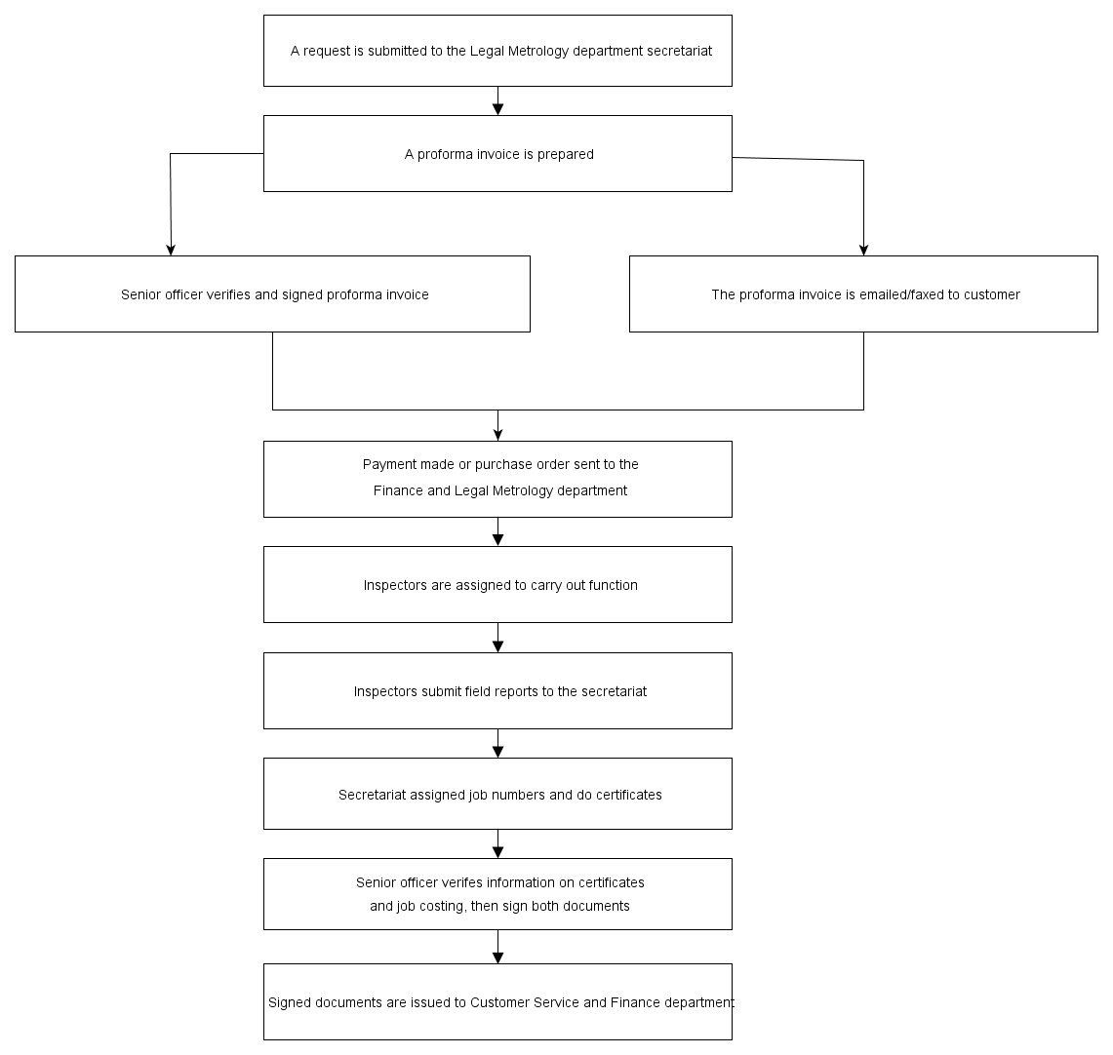

Figure 2 – Modified Testing and verification of weighing and measuring devices

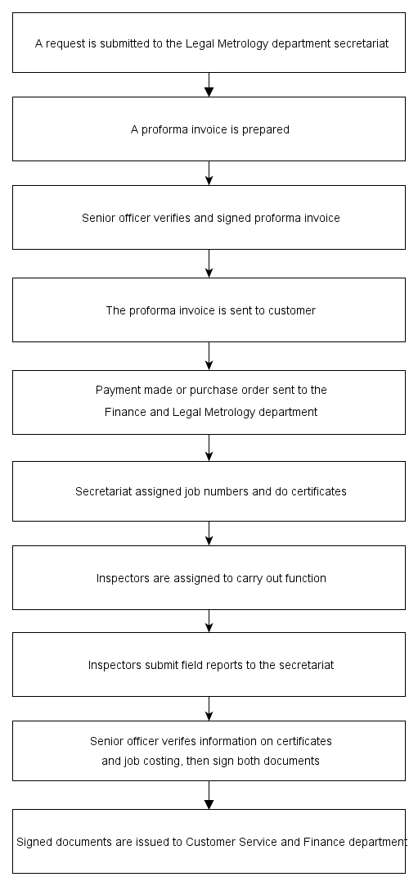

Figure 3 – Service Request and Job Tracking Process

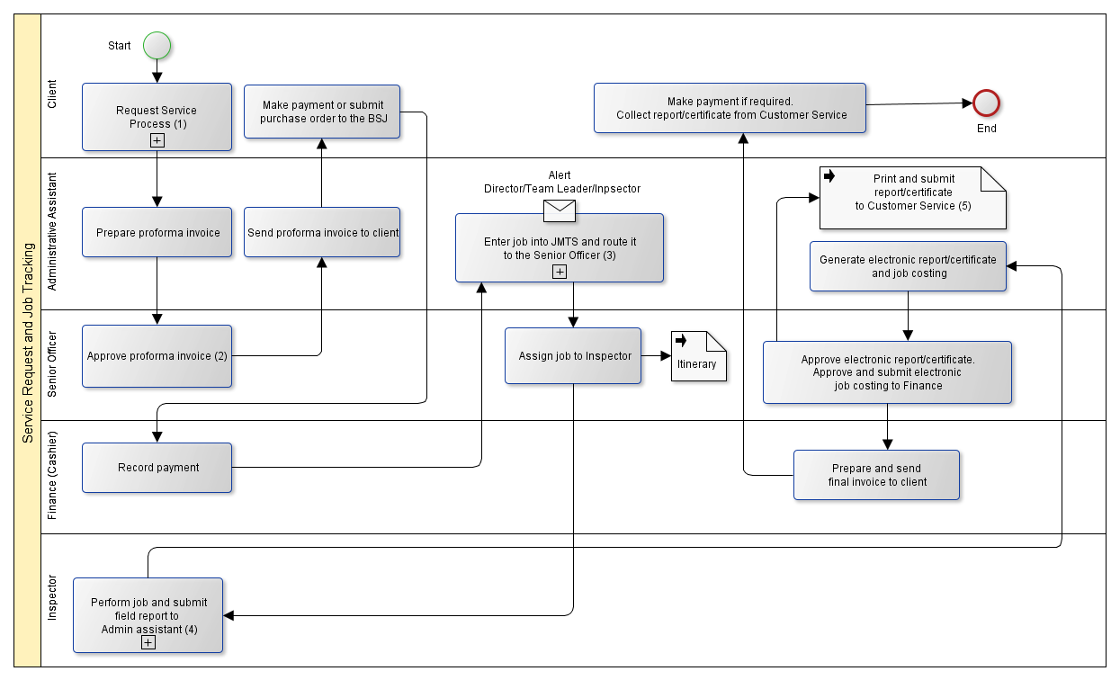

Note:

1. The Service Request Process is initiated by the client. The client can request a service by (i) filling out and submitting a form via the BSJ’s website (ii) emailing or faxing in filled out service request form or (iii) filling out a printed form and submitting it to the BSJ.
2. The senior officer who approves a proforma invoice will be able to see the service request documents submitted by the client before approving the proforma invoice. This proforma invoice will standardized throughout the BSJ.
3. Any change made to the data stored in the Job Management and Tracking System (JMTS) that may affect the integrity of the information extracted from the database requires the approval of a director or team leader.

An “Information Access Control” procedure will determine who will be able to view or update the data stored in the database and generate/view reports. For example, the Executive Director will be given read access to all data however he/she will not be granted write access unless such privilege is specifically requested.

1. The process that the Inspector follows depends on the job being carried out.
2. Documents can only be printed after they have been approved electronically by the relevant authorized personnel.